OTP(one-time programmable) Controller

General Description
It has the following features:
- Read and program 32bits from/to XPM by AXI interface.
- The XPM is divided into 35banks, each bank’s right is decided by access right table.
- The OTP controller can by accessed in secure mode only.
- The first 3Kbs are protected by checksum.
- The password register can only be written once after power-on reset.

Architecture
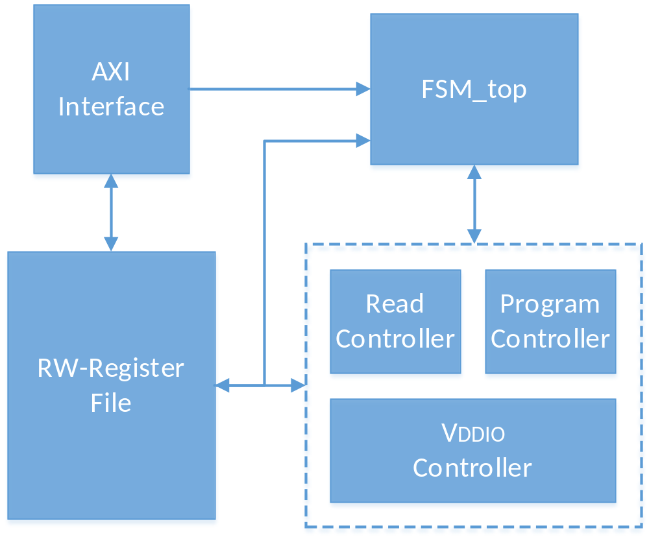
Figure : OTP Controller Architecture

Functional description
The otp controller use AXI Slave interface for register operation. The operation of XPM’s read and program is through register’s setting.
The XPM is divided into 35 banks, the 0~31 bank has 1Kbs, the 32~34 banks has 32Kbs. Each bank has it own access right, which is stored in 0 banks.

